**DAILY ONLINE ACTIVITIES SUMMARY**

|  |  |  |  |  |  |  |  |  |
| --- | --- | --- | --- | --- | --- | --- | --- | --- |
| **Date:** | **08/06/2020** | | | | | **Name:** | **V ANJANA PAI** | |
| **Sem & Sec** | **IV sem & B section** | | | | | **USN:** | **4AL18CS094** | |
| **Online Test Summary** | | | | | | | | |
| **Subject** | | **COMPLEX ANALYSIS, PROBABILITY AND STATISTICAL METHODS** | | | | | | |
| **Max. Marks** | | **30** | | **Score** | | | **20** | |
| **Certification Course Summary** | | | | | | | | |
| **Course** | **Introduction to Cyber Security** | | | | | | | |
| **Certificate Provider** | | | **Great learning academy** | | **Duration** | | | **5.5 hours** |
| **Coding Challenges** | | | | | | | | |
| **Problem Statement 1:** Write a Java Program to check whether the given matrix is magic square or not.  **Program Statement 2:** Write a C Program to Generate All the Set Partitions of n Number Beginning from 1 and so on. | | | | | | | | |
| **Status: Executed** | | | | | | | | |
| **Uploaded the report in GitHub** | | | | | **YES** | | | |
| **If yes Repository name** | | | | | **lockdown-coding** | | | |
| **Uploaded the report in slack** | | | | | **YES** | | | |

Online Test Summary: 18MAT41 test was scheduled from 9:30am t0 10:10am. The portion for the IA was 2nd module there were 15 questions for 2 marks and the time assigned was 40 minutes the questions were mcq type.

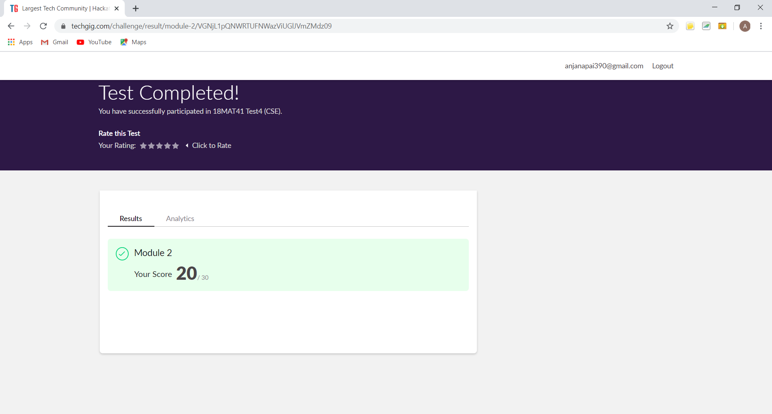

This is the snap shot of completion of test and the marks obtained in 18MAT41.

Online Certification Course Summary: In today’s session I learnt about Secure System Design, Threats and Vulnerabilities and also about What is Cyber Security.

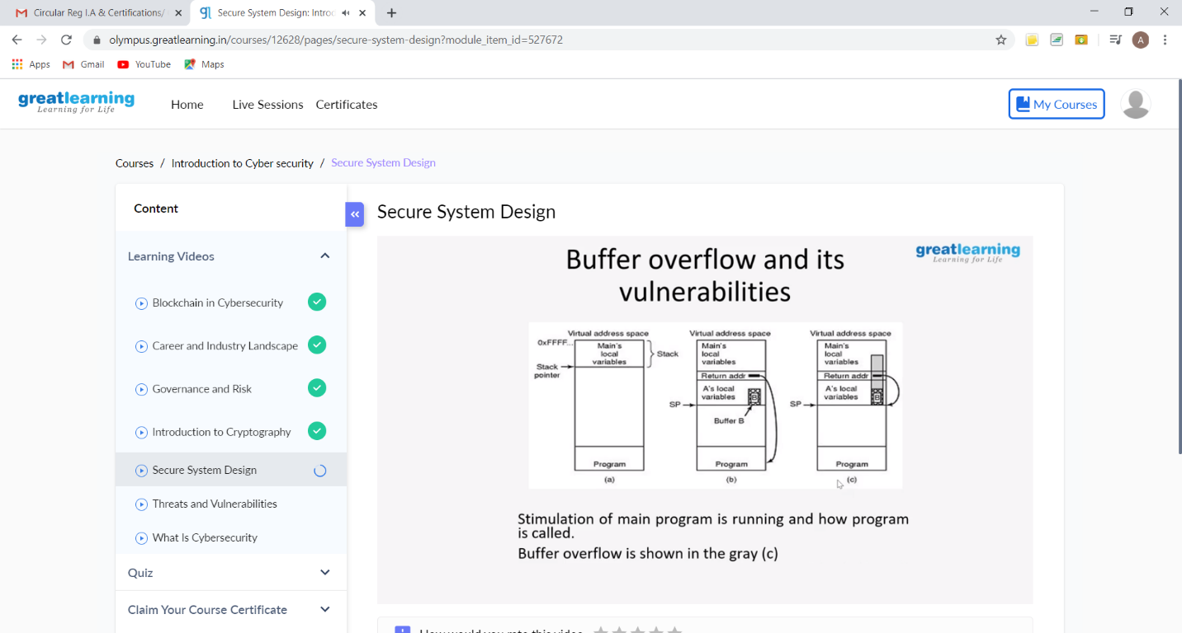

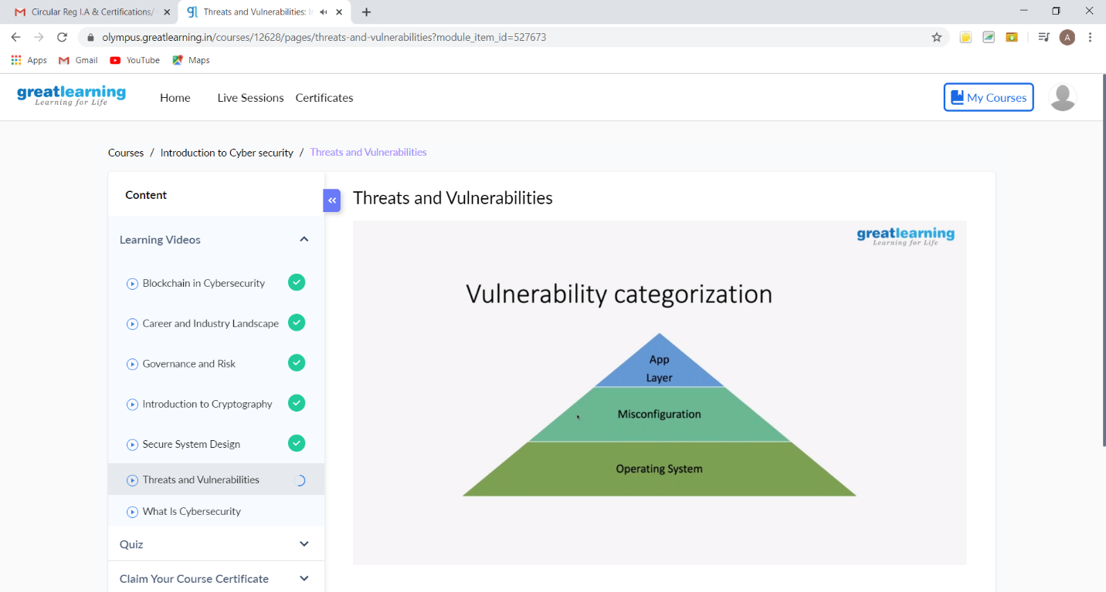

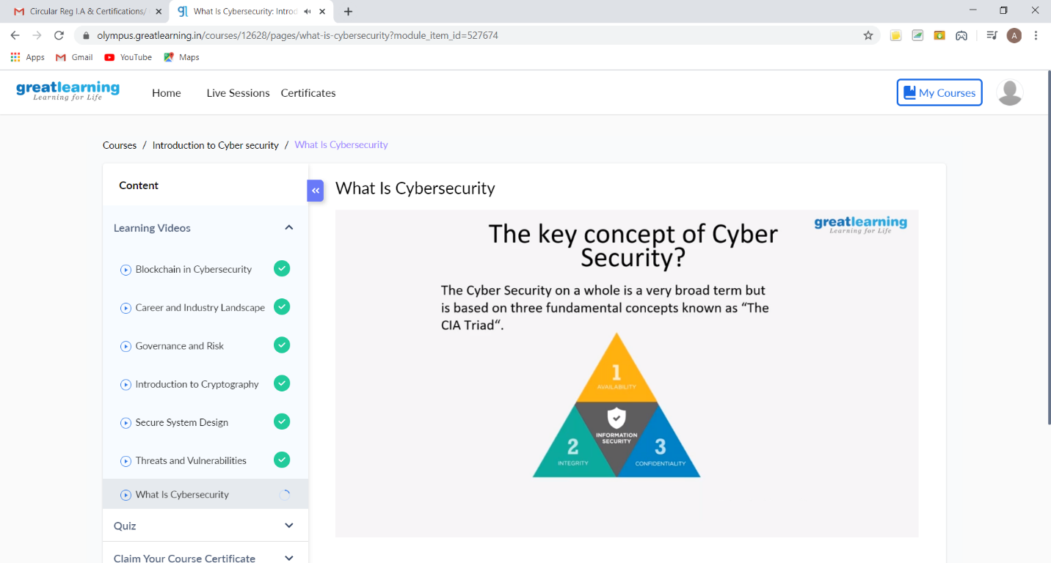

These are the Snap shots of today’s sessions.

Online Coding Summary: **Today I had received two programs from prof. Shilpa CSE Department and prof. Venkatesh CSE Department. The programs are mentioned above in the coding challenges(pg.01). I have also uploaded it to my GitHub repository.**

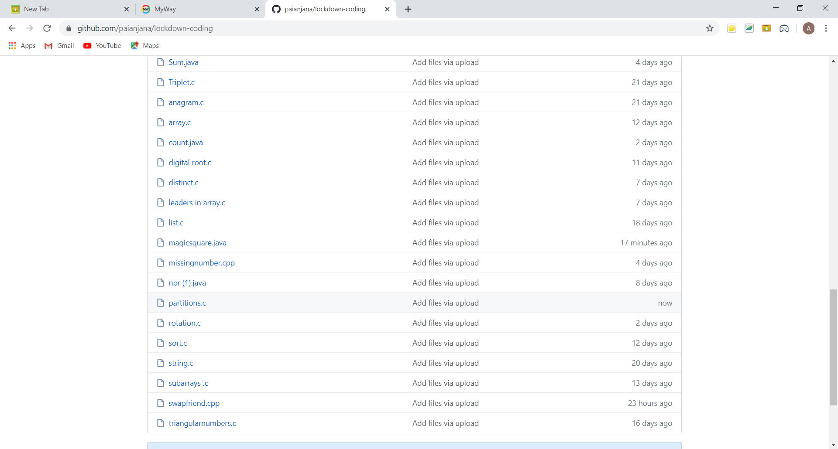

It is the snap shot of my repository where I have uploaded the code. File name is magicsquare.java and partitions.c.